**Abstract**

**Introduction**

Climate change is rapidly altering environmental conditions at the local level and in particular, temperature and precipitation regimes and the severity of weather events. How will plants, a mostly sessile taxa, cope with these rapid changes? Given the rapid change in local conditions, there are three ways plants can respond while avoiding extinction; quickly adapt, tolerate changing conditions through plasticity in phenotype that allows acclimation to the new conditions, or shift ranges. We conducted a study that focuses on the variation within populations and addresses the potential for the first two of these options in a widespread, weedy species.

The conditions across a species range are potentially heterogeneous and can have a variety of selective pressures that act on the populations differently. Divergent selection in two different locations can result in differing trait optima in separate populations, leading to local adaptation (Kawecki & Ebert, 2004). How a species adapts or acclimates to separate locations provides a clue to how a species in one location might respond as global warming changes local conditions. Temperature is a prominent variable that can determine species distributions and can vary greatly in both severity and consistency with geographic region. There have been many adaptations in different species that improve survival in extreme temperatures (citation), but how do populations of the same species persist in different temperature regimes? To understand local adaptation to diverging temperature regimes, we must understand the biology of plants under different termperature regimes and how they are vulnerable to extreme temperatures.

Temperature can impact plant physiology and cell structure in a few ways. Temperature stress changes the fluidity of phospholipid bilayers. Heat increases fluidity and dissociation, while cold decreases lipid adhesion and increases rigidity. Both heat and cold stress results in cytoplasm leaking from the cell membrane. Plants that are more tolerant of temperature stress would have the capacity to maintain cell membrane fluidity and reduce cytoplasm leakage. High temperatures also decrease the affinity of Rubisco (enzyme responsible for carbon fixation in photosynthesis) to CO2 and increase its affinity to O2 (Bauwe et al., 2010; Zhu et al., 2018). The fixation of O2 produces compounds that are needless and requires photorespiration to recycle components necessary for photosynthesis, in the process, reducing the efficiency of photosynthesis (Bauwe et al., 2010). In extreme temperatures, hot and cold, proteins and enzymes can be damaged or rendered inactive. This can have an immense effect on photosynthesis because the protein complexes in photosystem II and the electron transport chain can unfold (Zhu et al., 2018). The degradation of integral proteins and enzymes can also lead to the production of reactive oxygen species (ROS) through the excess absorption of light energy and prolonged excitation of chlorophyll molecules (Mishra et al., 2019; Wahid, 2007; Wahid et al., 2007). Chlorophyll excitation isn’t exclusively in the thylakoid membrane, where the light reaction typically takes place. Temperature stress can damage thylakoid membranes releasing chlorophyll. Chlorophyll will continue to absorb light energy even when free from the membrane. Excess energy from chlorophyll forms free radicals which are donated to oxygen molecules forming reactive oxygen species (ROS), which are highly reactive and damaging to cellular components. Therefore, plants typically degrade free chlorophyll or transform chlorophyll into alternative configurations quickly, reducing the chlorophyll fluorescence (Kariola et al., 2005). Plants that are capable of tolerating temperature stress would have less chlorophyll degradation. Oxidative stress due to ROS hinders physiological mechanisms such as photosynthesis, metabolism, and cellular structure directly or indirectly by reacting with metabolites or damaging macromolecules. Some of these cellular processes are not unique to diploid cells of the plants (sporophyte), but also occur in the haploid cells such as pollen and ovules (gametophyte). Extreme temperatures can limit pollen production, tube growth rate, and viability (Gajanayake et al., 2011; Kakani et al., 2002; Singh et al., 2008).

There is variation in the sensitivity to temperature stress and thus adaptations do lead to populations that are less sensitive. For example, cell membrane stability can be maintained in high or low temperature stress with the incorporation of fatty acids (Zhu et al., 2018) or sterols (Dufourc, 2008a, 2008b; Valitova et al., 2019). The production of heat shock proteins, a chaperone protein, also reduces temperature stress by preserving the shape of other proteins and enzymes required for normal function (Frank et al., 2009; Goswami et al., 2010; Knight & Ackerly, 2001; Lin et al., 2018; Liu et al., 2016; Nurminsky et al., 2018; Rhoads et al., 2005).

Adaptation to extreme thermal conditions would require that temperature must be a selective pressure that influences the survival or reproduction of the species. In angiosperms, selection can act independently in the two life stages, the sporophyte (diploid; full plants, vegetation) and the gametophyte (haploid; ovules, pollen). It has been shown that there is a substantial overlap in genes and gene expression between the two stages (Beaudry et al., 2020; Pedersen et al., 1987; Tanksley et al., 1981b; Willing & Mascarenhas, 1984). There is also evidence of a correlation between the gametophytic and sporophytic stages in temperature tolerance traits (Hedhly et al., 2005; Poudyal et al., 2019).

In this study, we compared plants from Minnesota and Texas for temperature tolerance to extreme hot and cold conditions. Since temperature-based selection in the two life stages has the potential for inter-generational adaptations, we incorporated variables from both stages. Sporophytic tolerance was measured using leaf measurements such as net photosynthesis, chlorophyll fluorescence, and cell membrane stability. The gametophytic variables were pollen germination (viability) and pollen tube growth rate. The first objective was to 1) determine if local thermal conditions have divergently selected for temperature tolerance traits to fit regional climate regimes. We hypothesized that if the temperature regimes in the north and south have resulted in divergent selection and local adaptation of temperature tolerance, then the plants in the north would be more tolerant of cold stress and plants from the south would be more tolerant of heat stress. The second objective was to 2) determine if there is a correlation between temperature tolerance in the gametophyte and sporophyte. If temperature stress is similar in both stages and gene expression patterns in the gametophyte and sporophyte overlap, then there would be a positive correlation for temperature tolerance in the two life stages.

**Methods**

***Plant Collection***

HOW ABOUT A SHORT DESCRIPTION OF HORSENETTLE HERE INCLUDING TAXONOMY, BREEDING SYSTEM, ASEXUAL REPRODUCTION, CENTER OF ORIGIN, RANGE AND POLLINATION CHARACTERISTICS

*Solanum carolinense* (Solanaceae)plants from three populations in Texas and two populations in Minnesota were collected between October 2019 and August 2020 (Figure 1). The three southern populations were from Colin County, Texas near McKinney (Oil Patch: 33.173465 N, -96.615402 W; Reserve: 33.159962 N, -96.619011 W; and Cemetery: 33.173672, -96.615096 W). Each population consisted of between 10 and 50 plants in the fruiting stage of their life history. The Reserve population was located approximately 1.5 km from the Oil Patch and Cemetery populations which were adjacent to each other (Figure 2). The two populations from the north were from Houston County, Minnesota and from here on will be referred to as plants from the northern region or Prairie Island (44.07959 N, -91.684545 W) and Frontenac (44.523056 N, -92.338611 W). These populations are separated by approximately 50 miles (figure 3). In Colin County TX, the average monthly low temperature is 18°C (65°F) and the average monthly high is 43°C (111°F). In Houston County, MN, the average, the average monthly low temperature is -14°C (7°F) and the average monthly high is 29°C (85°F).

*Solanum carolinense* is a rhizomatous, herbaceous perennial that disperses via sexual reproduction with a tomato-like fruit and by growing ramets from the rhizomes. Therefore, plants in close proximity may be genetically identical or ramets. To avoid sampling two plants of the same genotype, plants with a minimum inter-plant distance of 1 meter were collected. Collections involved digging up and cutting rhizome of at least 10 cm and placing them in ziplock bags. Rhizomes were stored in a cooler with blue ice and shipped to Fargo, where the collections were stored in a 4°C refrigerator. The rhizomes were potted in one-gallon containers and grown throughout the summer of 2020. In October, all above ground matter was cut and the rhizomes were again stored in a 4°C refrigerator to induce a period of dormancy.

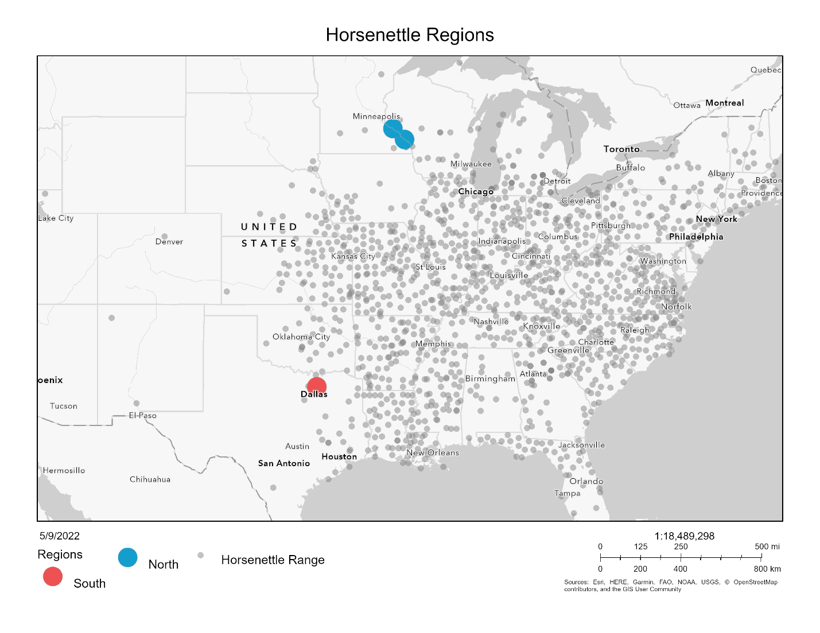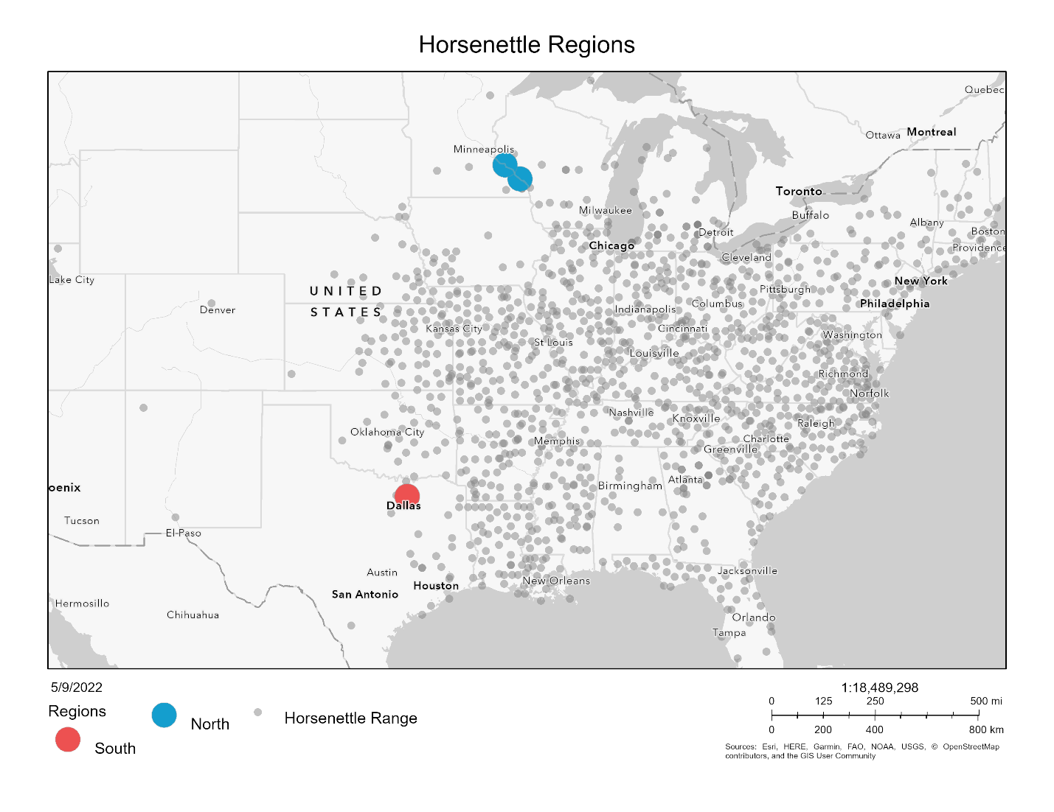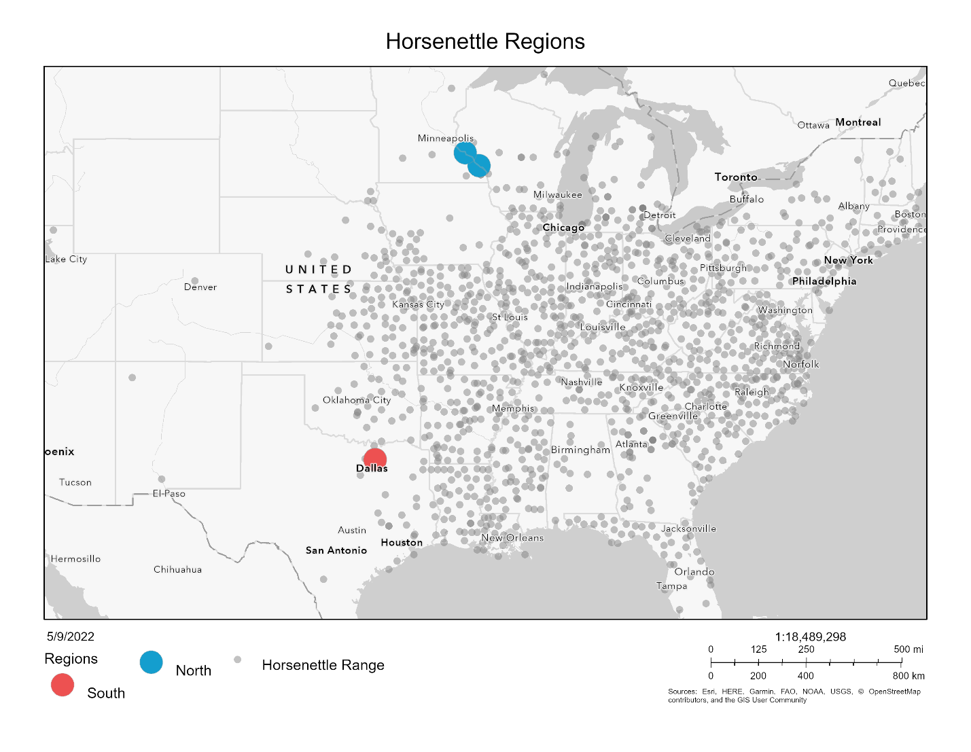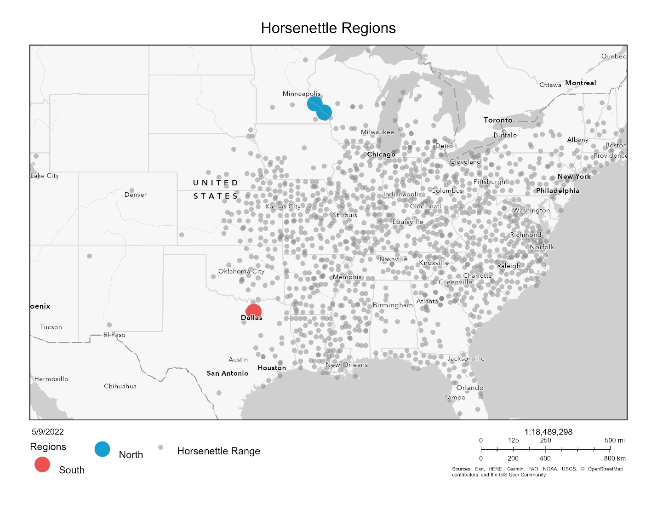

Figure 1. Map with collection site. Northern sites in blue and southern sites in red. Grey points indicate sites where *Solanum carolinense* was observed (data from EddsMaps).

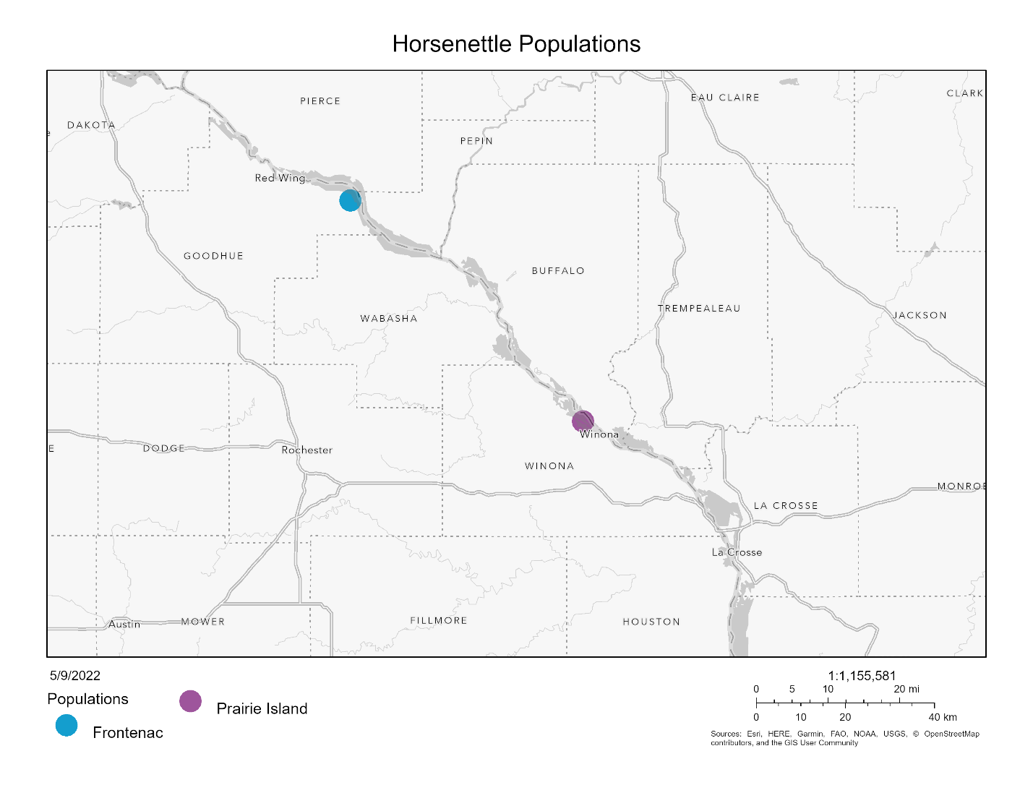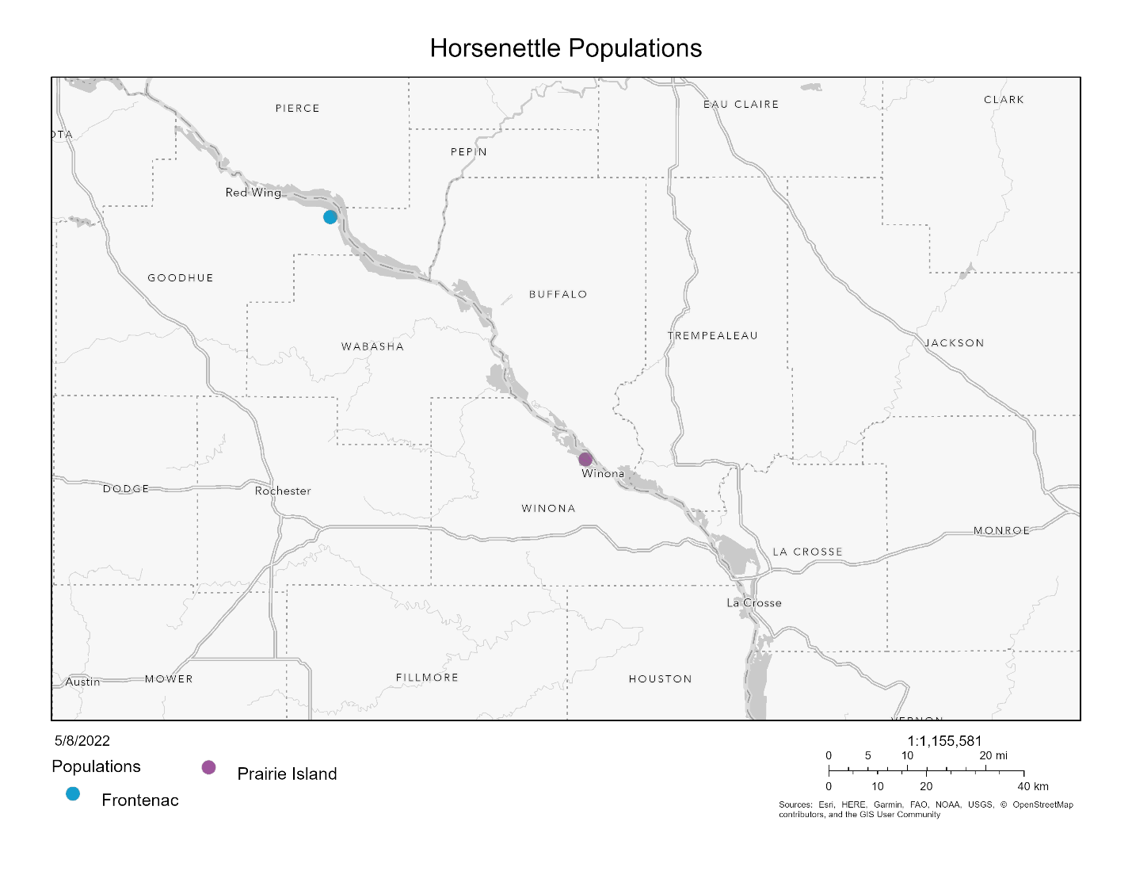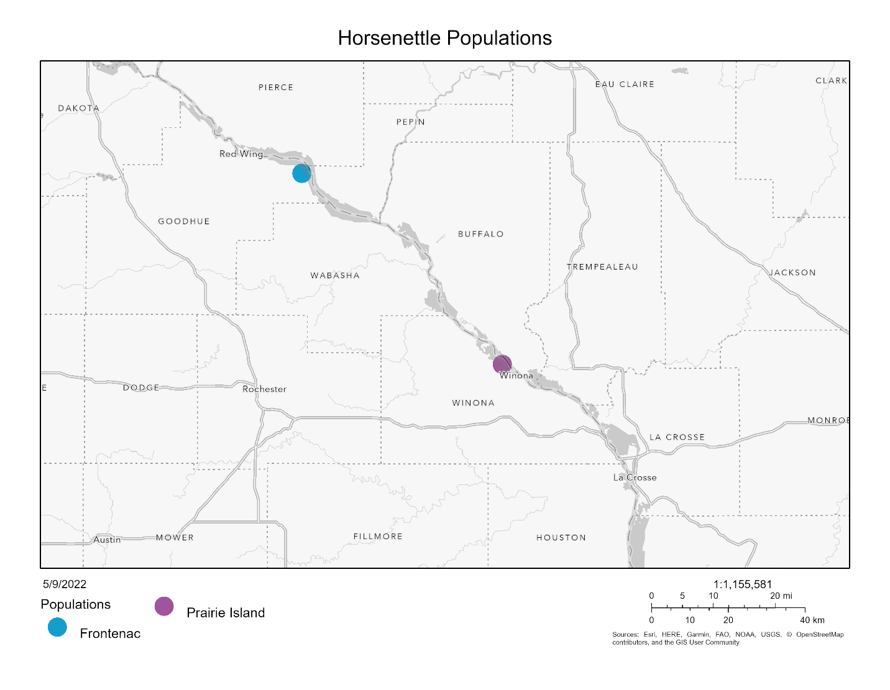

Figure 2. Populations in the northern region. Frontenac in blue and Prairie Island in purple.

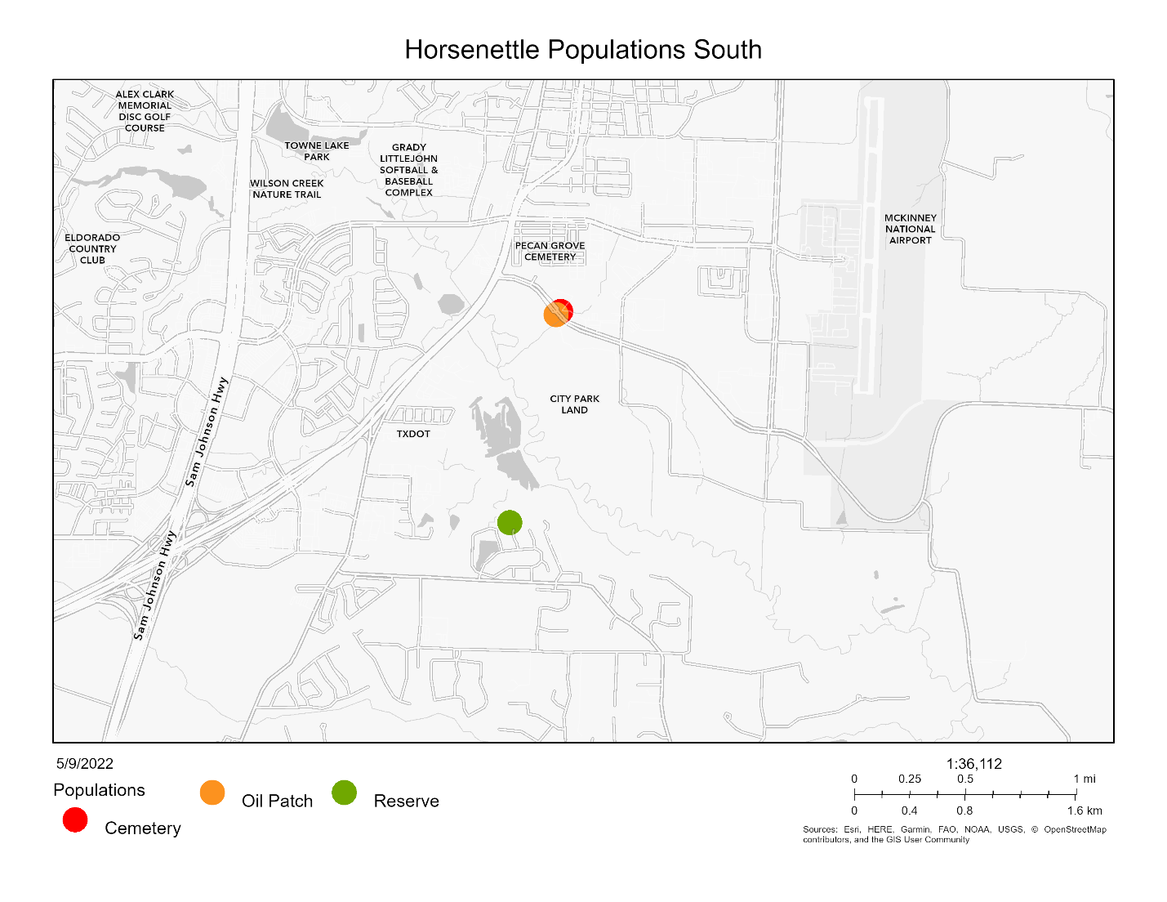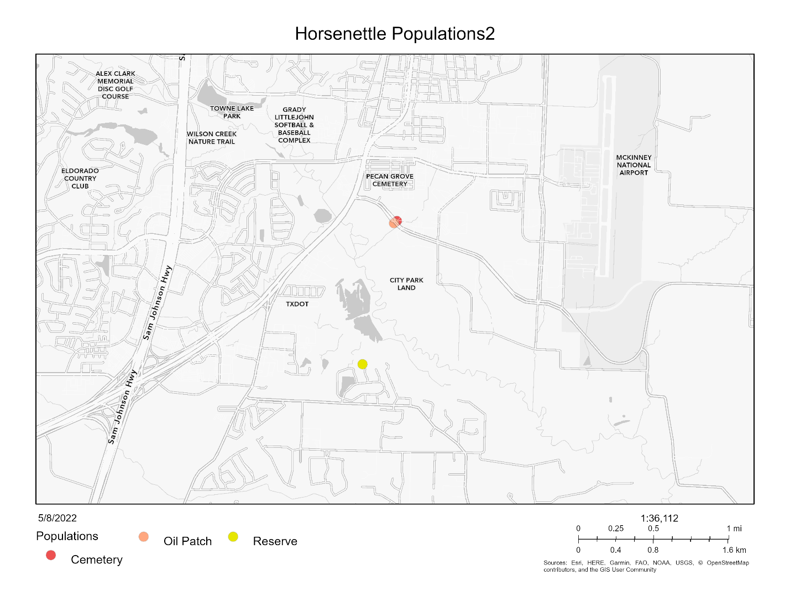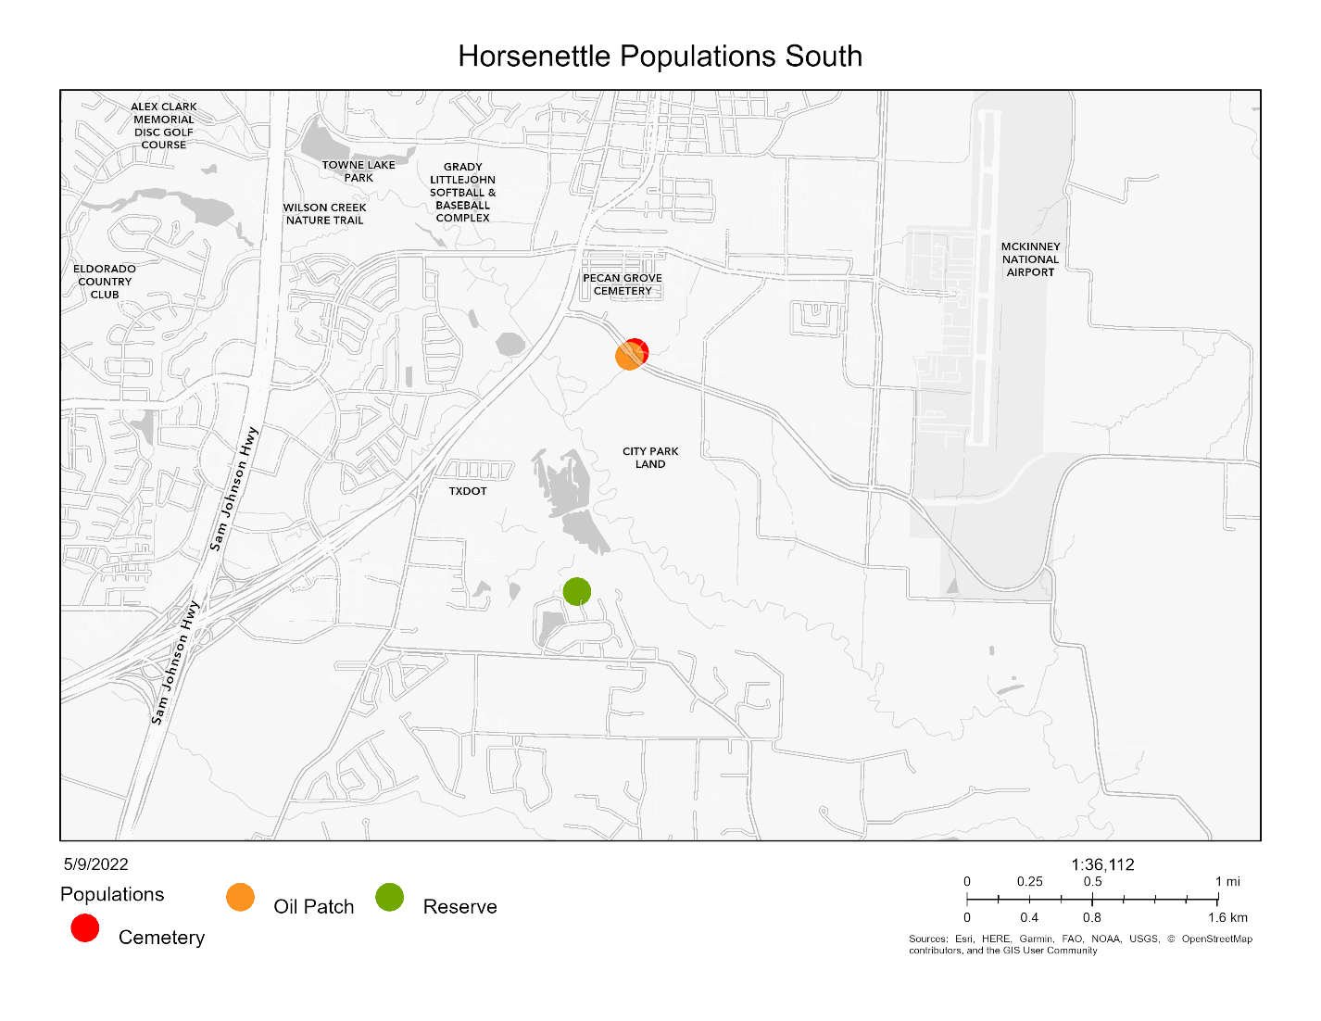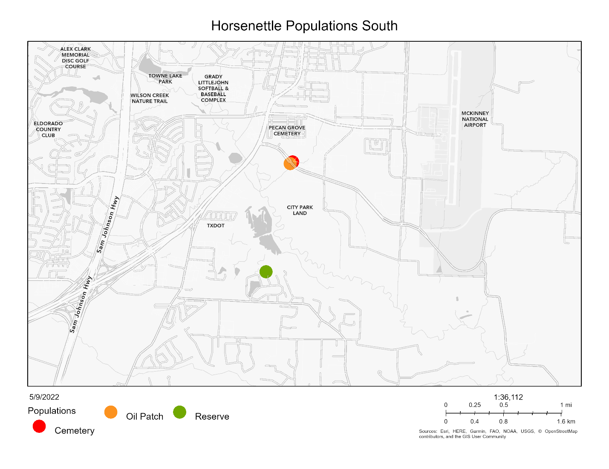

Figure 3. Populations in the southern region. Cemetery in red, Oil Patch in orange, and Reserve in green.

***Greenhouse Experiment***

After the dormancy period (3 months), equal sections of rhizome were cut to grow ramets (genetically identical copies) in cone-shaped containers in the greenhouse. In total, four ramets (blocks A, B, C, and D) were grown from each genet (genetically independent), separated temporally. We started 10 or 12 ramets each week (sub-block 1-20), randomly selected from the 52 genets. Of the 10 or 12 ramets planted each week, half were from the southern region and half were from the northern region. All ramets in block A were planted over five weeks prior to the planting of the ramets in block B and so on. The northern ramets were randomly assigned to either the left or right side of the respective southern pair within the tray that held the cone-shaped containers. The plants were fertilized regularly and transplanted to larger containers when they outgrew the small cone-shaped containers. Once the plants had leaves of a reasonable size, we began collecting sporophytic measurements from one sub-block each week. Gametophytic data were measured when plants began flowering.

***Sporophytic traits***

*Chlorophyll Fluorescence Stability*

We used a chlorophyll meter to measure chlorophyll fluorescence stability (CHPL). Two intact leaves were removed from the middle of the plant. One leaf was used for the heat treatment and the other was used for the cold treatment. Each leaf was cut in half and one half was placed in the treatment temperature and the other half was placed in the control of room temperature. The CHPL was measured for both halves before and after the temperature treatment.

The high temperature treatment was 60°C for 1 hour. The leaf halves in the cold treatment were subjected to 4°C for 1 hour followed by 1 hour in -18°C. The leaf halves were moved to room temperature for two hours prior to the second cold treatment measurement. Leaves in all treatments were kept in complete darkness.

The CHPL value was calculated as the inverse of the proportion of treatment final to treatment initial divided by the proportion of the control final to control initial. Thus, larger values indicate

$$CHPL= 1-\frac{{{Treatment}_{final}}/{{Treatment}_{initial}}}{{{Control}_{final}}/{{Control}_{initial}}}$$

Cell Membrane Stability

We used a handheld conductivity meter to measure cell membrane stability (CMS) after a temperature treatment. Two large, intact leaves were removed from the middle of a plant and rinsed with deionized water. One leaf was used for the high temperature treatment and the second leaf was used for the cold temperature treatment. Twenty leaf rounds were punched from each leaf with a hole puncher. Ten of the 20 leaf rounds were placed in a test tube for the temperature treatment (high or low) and 10 were placed in a test tube for the control treatment.

Prior to the high temperature treatment, 10 mL of deionized water was added to the control and temperature treatment test tubes. The high temperature treatment test tubes were placed in a water bath at 55°C for 20 minutes, while the control test tubes were left at room temperature. Both tubes were moved to room temperature for 10 minutes prior to the first conductivity measurement.

The low temperature treatment test tubes were placed at 10°C for 24 hours followed by 24 hours at 4°C to acclimate the leaf rounds to cooler temperatures. The treatment tubes were then placed at -18°C for 1 hour. The control treatment test tubes remained at room temperature. 10 mL of deionized water were added to all test tubes in both treatment and were placed at room temperature for 1 hour prior to the first conductivity measurement.

All treatments groups were subjected to a maximum damage treatment after the first conductivity measurements to control for absolute amounts of leaf material. All test tubes were placed in a water bath at 98°C for 1 hour and then left to cool at room temperature for 15 minutes before the second conductivity measurement.

The cell membrane stability value (CMS) used for data analysis was calculated as one minus the proportion of treatment final to treatment group maximum divided by one minus the proportion of control final to control group maximum conductivity. Thus larger values indicate higher tolerance of temperature stress.

$$CMS= \frac{{{1-(Treatment}_{value}}/{{Treatment}_{max})}}{1-({{Control}_{value}}/{{Control}_{max})}}$$

Net Photosynthetic Rate

We used a LI-6400 infrared gas analyzer with a red/blue light source to measure photosynthetic rate before and after the temperature treatment. The following settings were used for photosynthesis measurements: flow rate 500 μmol s-1, reference CO2 420 μmol CO2 mol-1, reference H2O 0 mmol H2O mol-1, ParIn_μml 400 μmol m-2 s-1.

The high temperature treatment was 33°C and the low temperature treatment was 10°C. Each ramet was subjected to both treatments with a rest period of one week between the temperature treatments. Ramets A and C were subjected to the high temperature treatment first and ramets B and D were subjected to the low temperature treatment first. The proportion of the photosynthesis measurement after the treatment to before was calculated as our measure of photosynthesis rate (PS). Any values below zero and above one were omitted prior to analysis.

$$PS= \frac{{Net Photosynthetic rate}_{final}}{{Net Photosynthetic rate}_{initial}}$$

***Gametophytic Traits***

We measured two pollen traits as estimates of male thermotolerance during the gametophytic stage: 1) the propensity for pollen grains to germinate (pollen germination) and 2) the growth rate of pollen tubes after being exposed to extreme hot and cold temperatures. Once a plant from the north and from the south flowered, we removed a mature flower from both plants. Since *Solanum carolinense* is buzz pollinated, a device crafted from a nose hair remover and a paper clip was used to mimic the vibrations needed to release pollen from the anther. Pollen from each flower was thus dispersed over five petri dishes containing a 3% Bacto-Agar based growth medium (sucrose, Ca(NO3)2, MgSO4, KNO3, H3BO3). The dusted plates were each placed at one of the five temperature treatments (10°C, 20°C, 25°C, 30°C, 40°C) for 16 hours. After the temperature treatments, each plate was covered with a thin layer of ethanol to halt further pollen tube growth and stored until data collection could begin. Four pictures of each plate were taken using a microscope .

Pollen germination was measured by counting the number of pollen grains that produced pollen tubes and the number of pollen grains that did not produce pollen tubes in the first quadrant of each plate. Pollen germination was considered as the production of a tube that was at least half the diameter of the pollen grain. We used the percent of pollen grains with tubes out of the total number of pollen grains as our measure of pollen germination.

Pollen tube growth rate was determined by first, measuring the 10 longest pollen tubes in each of the 4 quadrants, using the software (CITATION) The actual length of each tube was calculated by calibrating each photo with a measurement of a stage micrometer. We calculated the mean of the 20 longest tubes out of the 40 measured per plate, and used that to estimate growth rate by dividing the length by the time allowed for growth (16 hours). Pollen tubes were only included if they were completely visible in the picture.

***Data Analysis***

All data were analyzed in R (version 4.1.2). In order to measure differences in sporophytic traits between regions and among genets, we used linear mixed effects models (LMM; function lmer). Region (north vs. south) was considered the fixed effect and block (A,B,C,D) and genet nested in population as random effects. We dropped the genet nested in population term for cell membrane stability and both random effects terms for hot net photosynthetic rate to avoid overfitting the model. Since the genet nested in population term was significant for some variables, we compared population and genets independently. Populations were compared using a linear mixed effects model (LMM; function lmer) with population as the fixed effect and block as the random effect. We used an analysis of variance model (stats; function aov) to determine if there were differences between genets for each of the sporophytic variables. Since there was a significant block effect in some of the variables, we compared plants from the north and south within block using a paired t-test (stats; function t.test). To determine if variation within the northern and southern regions differed, we used the bartlett’s test of homogeneity of variance (stats; function bartlett.test).

For the gametophytic variables, we fit temperature performance curves (rTCP: function nls.multstart) to the multiple temperature measurements taken for each plant that flowered. We fit two genets, one from the north and one from the south, with all 25 temperature performance curves available in the rTCP packages and used AIC values to select the quadratic_2008 and the weibull_1995 models. We opted to use the quadratic_2008 model because the temperature maximum values determined by the weibull_1995 model were infinite for some of the plants. From the quadratic curves of each plant that flowered, we extracted six cardinal values: the temperature minimum (germination or growth rate = 0), temperature optimum (germination or growth rate are maximized), and temperature maximum (germination or growth rate =0). We then used analysis of variance (stats; function aov) on each of the cardinal values to determine if there were differences between region and among genets.

We used correlation analysis (stats; function cor) to determine if there were any correlations between sporophytic and gametophytic variables. We conducted correlation analysis for all plants together and then the northern and southern plants separately. To incorporate relationships between all of the variables and examine amalgamated differences among regions and populations, we conducted principal component analysis (PCA) (stats; function prcomp). We first conducted PCA on all the sporophytic variables and all gametophytic variables separately and then both all of them collectively. Photosynthetic rate was not included because of limited sample size. We extracted the eigenvalues for the first three principal components for all three PCAs. The eigenvalues for each principal component were compared for the two regions using t-tests (stats; function t.test).

**Results**

***Sporophytic traits***

Chlorophyll Fluorescence Stability

(CHPL) (HCHPL) (CCHPL) F4to both heat and cold were (Table 1)amongF5, Table 1 In the hot treatment,n

Cell Membrane Stability

Cell membrane stability (CMS) equals the ratio of a conductivity measurement after a temperature treatment to a conductivity measurement after a maximum damage treatment. An increased CMS ratio indicates higher tolerance of the temperature treatment. When *Solanum carolinense* plants from the north were compared to the south, we found no significant difference in the hot treatment (HCMS), but there was a significant difference in the cold treatment (CCMS; Figure 4, Table 1). Southern plants had significantly higher cold CMS values than northern plants. We found a significant difference among genotypes in the hot treatment, but not in the cold treatment (Figure 5, Table 1).

Because we could not grow all the experimental plants at the same time due to lack of space, we made the above comparisons among regions and genotypes in five different temporal blocks over the course of the spring and summer. To avoid confounding treatments with temporal effects, plants from different regions were paired with each other within blocks. When we tested for the presence of block effects, we found significant effects for both hot and cold CMS (Figure 6). Plants grown at different times in the greenhouse had different CMS ratios. We started growing the plants in the winter and early spring and outside temperatures gradually rose during that time. Acclimation to higher temperatures later in the year could account for the block differences observed. In order to remove block effects, we conducted paired t-tests of northern versus southern plants for each of the variables. When plants from the north and south were compared for hot CMS (HCMS), there was a significant difference between the regions (Figure 6) but only in the first block. In that block, northern plants had a higher CMS in extreme heat than those from the south. For cold CMS (CCMS), there was a significant difference between regions for blocks B and C (Figure 6). In both cases, southern plants were more tolerant of the cold temperatures than northern plants.

Net Photosynthetic Rate

We used net photosynthetic rate after thermal stress as a physiological indicator of temperature tolerance. Net photosynthetic rate (PS) is the proportion of the net photosynthetic rate after the treatment (heat and cold) to the net photosynthetic rate before the treatment. Increased PS indicates higher temperature tolerance of the thermal stress. For both the cold (CPS) and hot (HPS) treatments, there was no significant difference between north and south (Figure 4). There were also no significant differences among blocks and genotypes for both the hot and cold treatments.

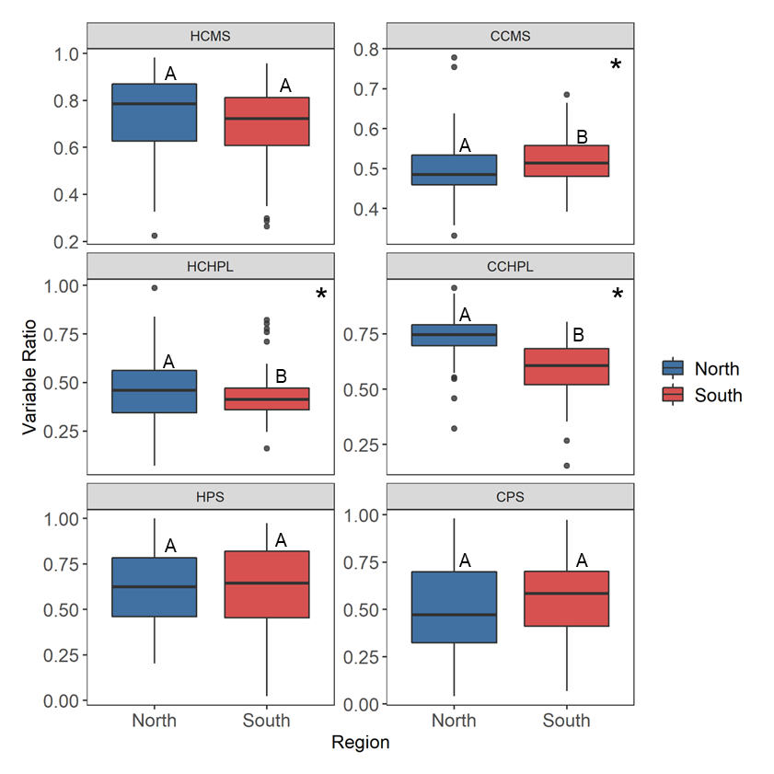Figure 4. Regional differences for temperature tolerance traits including hot and cold cell membrane stability (HCMS, CCMS), hot and cold chlorophyll fluorescence stability (HCHPL, CCHPL), hot and cold net photosynthetic rate (HPS, CPS). Center line of boxplot is the median value for the region. The letters represent statistically significant differences between regions. Variables with significant differences denoted with asterisks: CCMS (F1,50 = 7.792, p = 0.006), HCHPL (F1,51 = 4.334, p = 0.043), and CCHPL (F1,50 = 64.652, p = 1.6e-10).

Table 1. Results from the mixed linear model for the difference in region (north vs south) and the one-way analysis of variance results for the difference between individual genets. Red font color highlights observed outcomes when the result was different from the expected pattern. Asterisk indicates analysis with one outlier removed determined using Grubbs test for one outlier.

|  |  |  |  |  |  |  |
| --- | --- | --- | --- | --- | --- | --- |
|  |  | **Region** | | | **Genet** | |
|  | **Variable** | **Expected** | **Observed** | **p-value** | **Observed** | **p-value** |
| **Sporophyte** | Cell Membrane Stability (Heat) | S > N | - | 0.06102 | **Yes** | **0.013** |
| Cell Membrane Stability (Cold) | N > S | **S > N** | **0.0117** | No | 0.886 |
| Chlorophyll Fluorescence (Heat) | S > N | **N > S** | **0.0405** | No | 0.38 |
| Chlorophyll Fluorescence (Cold) | N > S | N > S | **9.96E-11** | **Yes** | **1.05E-07** |
| Photosynthetic Rate (Heat) | S > N | - | 0.997 | No | 0.127 |
| Photosynthetic Rate (Cold) | N > S | - | 0.77 | No | 0.883 |
| **Gametophyte** | Pollen Germination (Tmax) | S > N | **N > S** | **0.00037** | **Yes** | **0.0251** |
| Pollen Germination (Topt) | S > N | **N > S** | **0.000685** | **Yes** | **0.0351** |
| Pollen Germination (Tmin) | S > N | - | 0.331 | **Yes** | **\*0.0135** |
| Pollen Tube Growth Rate (Tmax) | S > N | - | 0.568 | No | 0.418 |
| Pollen Tube Growth Rate (Topt) | S > N | - | 0.77 | No | 0.608 |
| Pollen Tube Growth Rate (Tmin) | S > N | - | 0.683 | No | 0.496 |

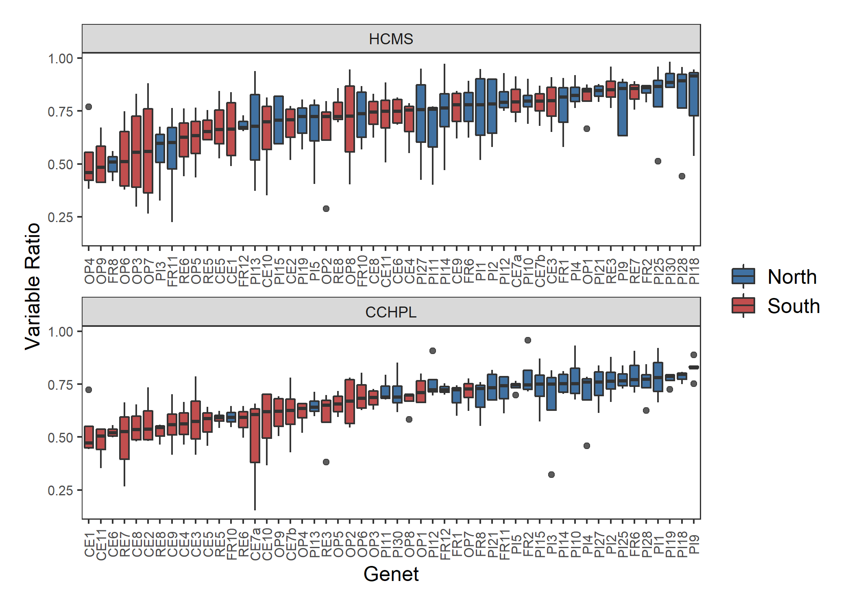

Figure 5. Genotype differences for temperature tolerance traits including hot cell membrane stability (HCMS) and cold chlorophyll fluorescence stability (CCHPL). Genets ordered by increasing ratio for each variable. Center line in boxplot is the median of the measurements taken for the ramets of one genet. There is a significant difference among the genets for HCMS (F = 1.5, p = 0.029) and CCHPL (F = 3.341, p = 6.1e-9). Plots of genet effect for other variables in appendix.

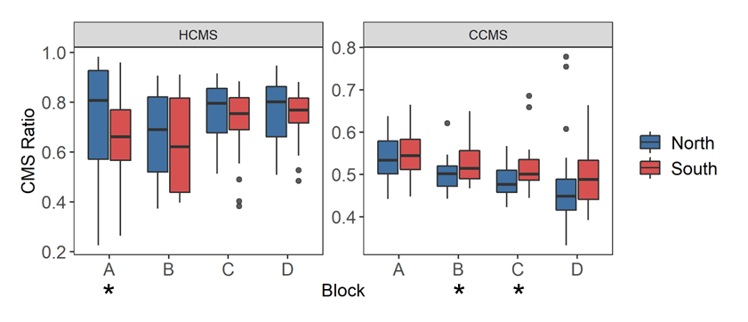

Figure 6. Cell membrane stability across temporally independent blocks and colored by region. The center line of the boxplot is the median of the measurements taken for each region within a ramet. There is a significant difference between blocks for hot cell membrane stability (HCMS, p = 0.0297) and cold cell membrane stability (CCMS, p = 7.30e-05). Astrisks indicate a significant difference between regions from a paired t-test of regions for each block independently. There was a significant difference between regions for HCMS block A (t = -2.910, p = 0.015), CMS block B (t = 2.190, p = 0.040), and CMS block C (t = 2.073, p = 0.049). Results from paired t-tests between blocks for each variable located in the appendix.

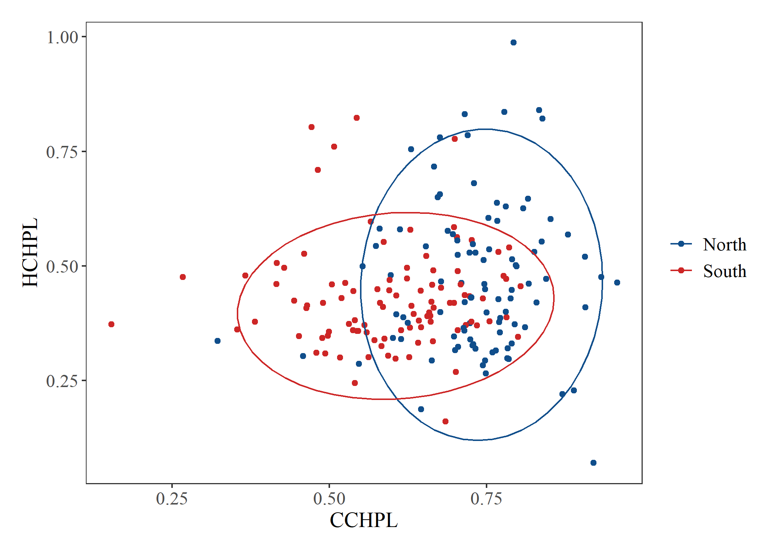

Figure 7. Hot chlorophyll fluorescence stability (HCHPL) vs cold chlorophyll fluorescence stability (CCHPL) for plants from the north and south. Ellipse indicating 95% confidence interval for multivariate T distribution. Results from Bartlett’s test for heterogeneity of variance between regions for all variable located in the appendix.

***Gametophytic Traits***

Pollen Germination

We fit quadratic curves to temperature performance profiles of each genet for pollen germination at five temperatures (Figure 7). From the quadratic fit, we calculated the minimum (Tmin), maximum (Tmax), and optimal (Topt) temperature of pollen germination for each individual. There was a significant difference between regions for Tmax and Topt (Figure 7, 8). Plants from the north germinated more readily at high temperatures and had higher thermal optima than plants from the south. There was no significant difference between the two regions for Tmin. The genets were significantly different from one another for Tmin, Tmax, and Topt (Figure 9). One outlier was identified using the Grubbs test for one outlier (outliers; function grubbs.test) and subsequently dropped from the analysis.

Pollen Tube Growth Rate

The pollen tube growth rates for each individual were also fit with a quadratic curve to estimate the Tmin, Tmax, and Topt. There were no significant differences between plants from the north and south for each of the three variables (Appendix). There were also no significant differences among genets (Appendix).

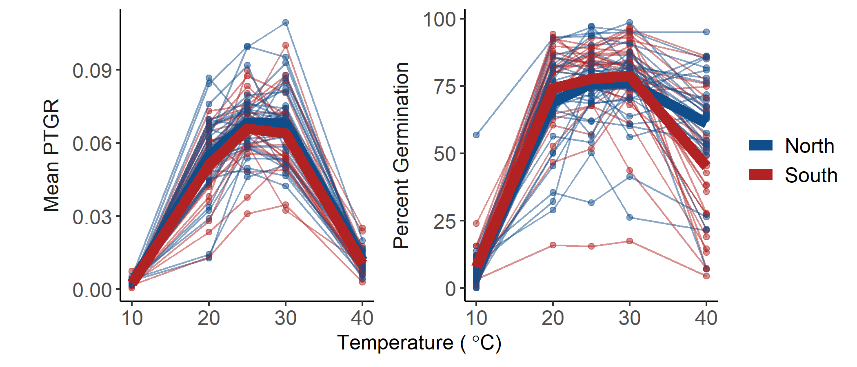

Figure 7. Percent germination and mean pollen tube growth rate (PTGR) for *Solanum carolinense* pollen grains from the north (blue) and south (red) across a temperature gradient (10°C, 20°C, 25°C, 30°C, 40°C). Thin lines and points represent each individual plant that flowered. Thick lines indicate the mean value for the region at each temperature.

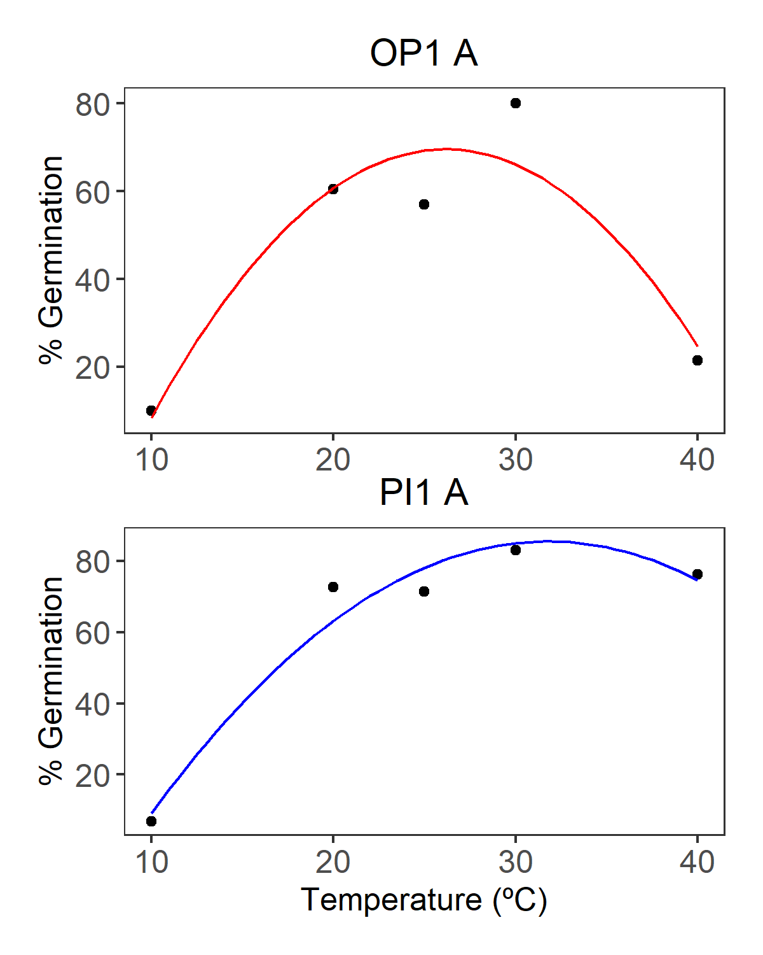

Figure 7. Examples of quadratic fit curve for pollen germination of one genet from the southern region (OP1 A, red) and one genet from the northern region (PI1 A, blue).

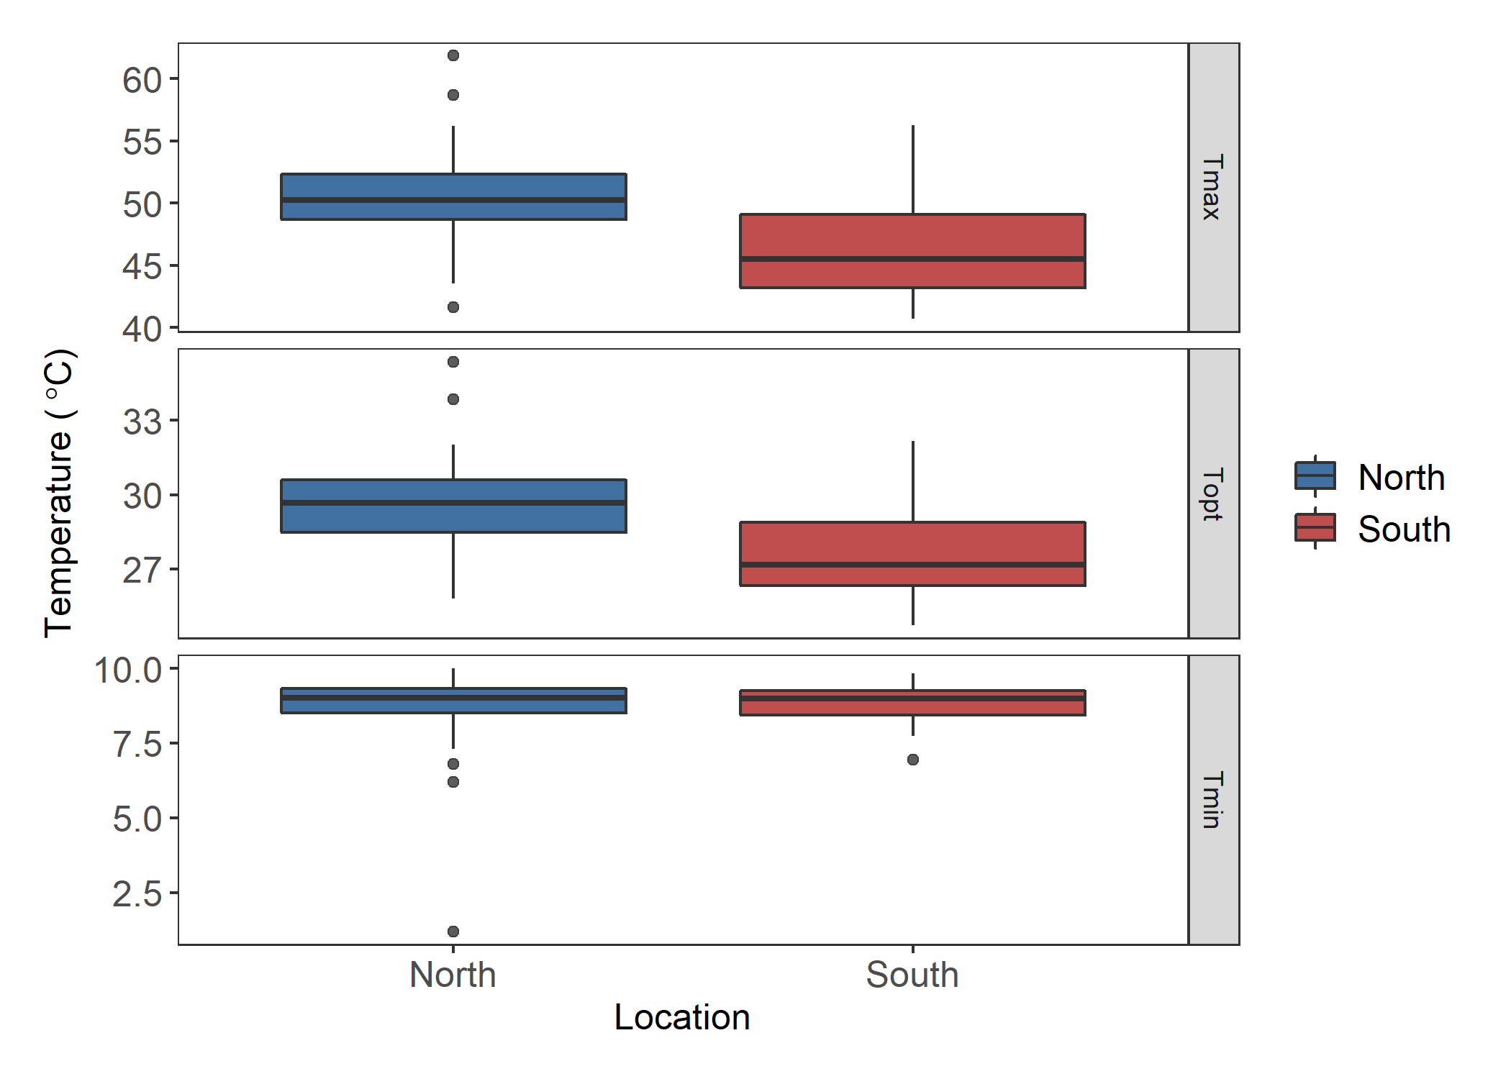

A

B

*

A

B

*

A

A

Figure 8. Estimates for the maximum (Tmax), optimal (Topt), and minimum (Tmin) germination temperature extracted from quadratic fits of the germination data for each individual. Asterisks and different letters indicate significant differences. There is a significant difference between regions for Tmax (F = 14.28, p = 3.7E-4) and Topt (F = 12.85, p = 6.85E-4).

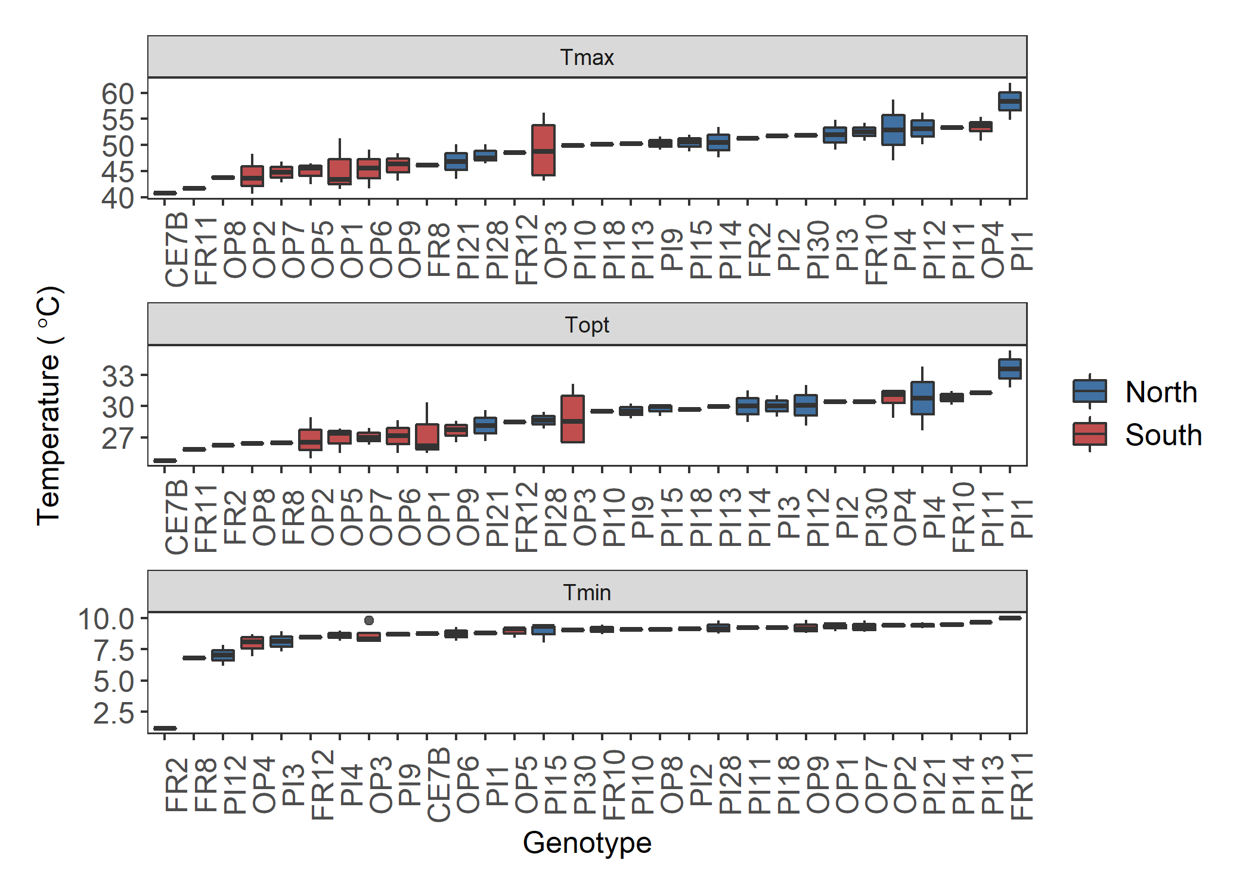

*

Figure 9. Boxplots of the maximum (Tmax), optimal (Topt), and minimum (Tmin) pollen germination temperatures by genet. There is a significant difference between the genets for Tmax (F = 2.064, p = 0.025), Topt (F = 1.952, p = 0.035), and Tmin (F = 2.284, p = 0.0135). Asterisk indicates the outlier removed for analysis. Plots of genet effect for other variables in appendix.

Figure 10. Correlation matrix of traits in northern plants. Sporophytic (dark gray font) and gametophytic variables (black font) with significant Pearson’s correlations for all study plants. Blue colors indicate positive correlations and red colors indicate negative correlations.

Figure 11. Correlation matrix of traits in southern plants. Sporophytic (dark gray font) and gametophytic variables (black font) with significant Pearson’s correlations are included. Blue colors indicate positive correlations and red colors indicate negative correlations.

***Correlations***

We used correlation analysis to identify relationships between hot and cold tolerance for the sporophytic and gametophytic variables. Pearson’s correlations were determined for all pairings of variables. When all plants were included, there were no significant correlations between the gametophytic and sporophytic variables (Appendix). However, three of the six sporophytic variables were significantly correlated (correlation plots located in appendix). HCMS was weekly correlated with HPS (correlation = 0.19), CPS (correlation = 0.2), and CCHPL (correlation = 0.15) There were also three significant correlation coefficients between gametophytic variables. Maximum and minimum pollen tube growth rate were positively correlated (correlation = 0.45). Maximum and minimum pollen germination were negatively correlated (correlation = -0.33). Maximum pollen tube growth rate and maximum pollen germination were positively correlated (correlation = 0.3).

When the correlation analysis was performed for the regions separately, there were different results. For the northern plants, there was only one significant correlation; between HPTGR and CPTGR (Pearson’s correlation 0.59; Figure 10). The southern plants had several significant correlations (Figure 11). There was a significant correlation between HCMS and HPS (correlation = 0.47), between cold germination (Cgerm) and hot germination (Hgerm) (correlation = -0.63) and between hot PTGR (HPTGR) and cold PTGR (CPTGR) (correlation = 0.51). In addition, there were correlations between variables in the gametophytic and sporophytic life stages. Cgerm was negatively related to CCMS (correlation = -0.37) and positively related to HPS (correlation = 0.63). Hgerm was also related to HPS (correlation = -0.57), but negatively. HCHPL and CPTGR were negatively correlated (correlation = -0.39), while CCHPL is negatively related to HPTGR (correlation = -0.41).

***Principal Component Analysis***

We conducted principal component analysis to further explore relationships among all variables and the sporophytic and gametophytic variables separately. For the full PCA, we included all gametophytic and sporophytic variables, except HPS and CPS due to inadequate sample size. The first three principal components accounted for 57% of the variation (full PCA plots and loadings in the appendix). There was little divergence between regions (Figure 12). When the eigenvalues of the principal components were compared between regions, PC2 was the only principal component that showed a significant difference (t58 = -2.69, p = 0.0092). Cold chlorophyll fluorescence (CHPL) loads primarily on PC2 and is likely driving the divergence between northern and southern plants.

*Sporophytic PCA*

In the sporophytic variable PCA, the first three principal components explained 60% of the variation. The variables HCMS and HPS primarily loaded on PC1 (Table 2, Figure 12). The second and third principal components were mostly influenced by CCHPL and HCHPL respectively. There was a significant difference between the regions for the eigenvalues extracted from both PC2 (t78 = -5.09, p = 2.39e-06) and PC3 (t101 = 2.38, p = 0.019). The divergence in PC2 can be explained by the opposite responses we observed for CCMS and both chlorophyll fluorescence treatments. Northern plants have a higher chlorophyll fluorescence ratio for both treatments, while southern plants had less cell membrane damage in the cold treatment. PC1 did divide HCMS and CCMS, suggesting an antagonistic relationship between the two variables, though there was no correlation between the two that was statistically significant. Hot and cold treatment variables were also divided on PC3. HPS and HCHPL were opposite in direction to CPS and CCHPL.

*Gametophytic PCA*

In the gametophytic PCA, the first three components explained 92.5% of the variance. Pollen germination variables divided the northern and southern plants (Figure 13). Tmax and Topt loaded evenly in the opposite direction of Tmin for both PC1 and PC2 (Table 3, Figure 13). There was a significant difference between north and south for the eigenvalues extracted from PC2 (t46 = -3.17, p = 0.0025). PTGR variables loaded evenly on the first two principal components and in the same direction.

Figure 12. Plots of the results of principal component analysis for the sporophytic variables. A) PC1 and PC2, B) PC2 and PC3, C) PC1 and PC3. Ellipsoid indicating 95% confidence interval. PC1 explains 22.38% of the variance, PC2 explains 21.55% of the variance, and PC3 explains 16.79% of the variance. Tables with principal component importance for PC1 through PC6 in the Appendix.

Table 2. Results from principal component analysis of only sporophytic variables. Loadings for each of the variables on the principal components

|  |  |  |  |  |  |  |
| --- | --- | --- | --- | --- | --- | --- |
|  | **PC1** | **PC2** | **PC3** | **PC4** | **PC5** | **PC6** |
| **HCMS** | 0.613999 | 0.02998 | 0.344975 | 0.147492 | 0.573797 | 0.390002 |
| **CCMS** | -0.35207 | 0.435008 | 0.204072 | -0.57534 | 0.520509 | -0.20789 |
| **HCHPL** | 0.284794 | -0.36797 | -0.33836 | -0.75803 | -0.08744 | 0.294536 |
| **CCHPL** | 0.117118 | -0.57752 | 0.579996 | -0.14114 | -0.03843 | -0.5431 |
| **HPS** | 0.577968 | 0.302596 | -0.40867 | 0.000171 | 0.044159 | -0.63673 |
| **CPS** | 0.264909 | 0.499375 | 0.470594 | -0.22955 | -0.6235 | 0.13244 |

Figure 13. Plot of the results of principal component analysis of the gametophytic variables. PC1 describes 48% of the variation and PC2 explains 27%. A table of importance of principle components 1 through 6 is in the Appendix.

Table 3. Results from principal component analysis on only gametophytic variables. Loadings for each of the variables on the principal components

|  |  |  |  |  |  |  |
| --- | --- | --- | --- | --- | --- | --- |
|  | **PC1** | **PC2** | **PC3** | **PC4** | **PC5** | **PC6** |
| **Germ.Tmin** | -0.01334 | 0.405643 | 0.812217 | 0.376238 | -0.00058 | -0.18446 |
| **Germ.Topt** | 0.418665 | -0.45436 | 0.390064 | -0.00262 | 0.001723 | 0.682727 |
| **Germ.Tmax** | 0.407763 | -0.5446 | 0.164764 | -0.10069 | -0.00179 | -0.707 |
| **PTGR.Tmin** | 0.367661 | 0.452838 | 0.127813 | -0.75119 | -0.28131 | 0.00071 |
| **PTGR.Topt** | 0.523981 | 0.308129 | -0.20261 | 0.123985 | 0.757676 | -0.00193 |
| **PTGR.Tmax** | 0.498538 | 0.180049 | -0.3219 | 0.518304 | -0.58888 | 0.001496 |

**Discussion**

***Regional Differences***

If *Solanum carolinense* has locally adapted to the respective temperature regimes in TX and MN, we would expect that plants from the north would be more tolerant of cold temperatures and plants from the south would be more tolerant of hot temperatures. Rather than a clear-cut difference between north and south for hot and cold treatments, there were mixed results that support divergence between regions in ways we hadn’t anticipated.

In contrast to our expectations, northern plants were generally more tolerant of extreme heat than southern plants. Plants from the north had more stable chlorophyll fluorescence in both the hot (HCHPL) and cold treatments (CCHPL) (Table 1). In addition, northern plants had higher cell membrane stability (HCMS) under some conditions (Figure 6) as well as higher maximal and optimal temperatures for pollen germination in comparison to southern plants (Table1). There was no significant difference between region for HCMS for all study plants together, but there was a significant difference for plants in block A. Temperatures in the greenhouse progressively rose throughout the spring and summer leading to a block effect in both the hot and cold treatments of CMS. In block A for HCMS measurements, northern plants had a higher HCMS, but this difference degraded in the later blocks during the times when temperatures were higher. A possible explanation for the block effect on CMS is that southern plants may have the capacity to induce heat tolerance as they acclimate to warmer conditions. Block A may be the best representative measurement of baseline heat tolerance for HCMS, and later blocks may represent induced heat tolerance (citation).

Why would northern plants have greater baseline tolerance of heat in cell membrane stability, chlorophyll and pollen germination traits than southern plants that grow in relatively high maximum temperatures?

Stable chlorophyll fluorescence in heat and cold for northern plants may be explained by northern plants experiencing a larger range of temperatures. Between 2018 and 2021, temperatures during the growing season (March to September) in Houston County, MN ranged from -28°C to 34°C (62°C difference), while in Collin County, TX they ranged from -7°C to 42°C (49°C difference). Since the temperate conditions of Minnesota are more variable and rarely exceed temperatures likely to stop plant growth (Hatfield et al. 2011) populations in the north may have evolved to to acclimate to temperature stress while plants in the south do not. Furthermore, northern plants also had significantly more variation in HCHPL than southern plants. This may suggest that there is stabilizing selection occurring in the southern region for heat tolerance in chlorophyll stability. Less variation in HCHPL in the south may contribute to the counter-gradient results we attained. If northern plants experience less heat stress selection and have greater variation, then there may be more potential to have individuals with high HCHPL.

Pollen from the north had a higher propensity to produce pollen tubes at high temperatures than their southern counterparts. Pollen germination was higher in pollen grains from the northern plants than those in the south for both Tmax and Topt (Table 1). The distinct difference between north and south suggests that there might be sensitivity to high temperatures and an adaptive response occurring in the populations of the south. Rutley et al. (2022) proposed the two-baskets model categorizing pollen, which states that there are high-ROS (reactive oxygen species) and low-ROS subpopulations of pollen within anthers of flowering species. The low-ROS pollen have a lower metabolic rate than high-ROS pollen due to partial dehydration during development. The two subpopulations of pollen are adaptive as they allow for asynchrony in pollen germination, permitting some pollen to remain dormant in a stressful environment and grow pollen tubes later in more favorable conditions. Keller et al. (2018) found that *Solanum lycopersicum* (tomato) pollen had two responses during heat stress – direct and delayed translation. Luria et al. (2019) later showed that *Solanum lycopersicum* has pollen that fall in the low-ROS and high-ROS groups, supporting the two-basket model in a species closely related to *Solanum carolinense*. We hypothesize that *Solanum carolinense* populations in the south have higher proportions of low-ROS to high-ROS pollen grains than those in the north due to stronger selection from increased exposure to extreme heat in the south. Low-ROS pollen that remains dormant would not be adaptive in northern populations, with little exposure to high temperature stress.

There was a significant negative correlation between Tmax and Tmin germination. This correlation was driven by plants from the south and supports the two-basket model. The negative correlation means that plants with pollen that germinate readily at high temperatures also germinate at low temperatures, while those that have a lower Tmax have a higher Tmin. Plants with a higher proportion of high-ROS pollen would germinate in any condition (extreme heat and cold stress). Plants with a higher proportion of low-ROS pollen would not germinate as freely during stressful conditions. Since plants of the south have likely evolved to have the dual pollen types, there may be more variation in pollen activity driving this correlation. Southern plants also had a correlation between Tmax gemination and Tmax PTGR, meaning that if plants have pollen that germinate at higher temperatures, they also have pollen tubes that grow faster at high temperatures. PTGR is likely influenced by metabolic rate, which is increased in high-ROS pollen. There was a positive correlation between Tmin and Tmax PTGR in the north. This pattern indicates that pollen tubes either grow fast at high temperatures or low temperatures, but not both. When north and south were combined, there were positive correlations between germination and PTGR Tmin and between germination and PTGR Tmax, indicating that the response to temperature for gemination and pollen tube growth are related.

There was no significant difference between northern and southern plants for net photosynthetic rate in both the hot and cold treatments. Net photosynthesis was the only sporophytic variable where the whole plant was placed in a temperature treatment and leaves were measured on the plant. The plant may compensate for temperature stress through physiological mechanisms, such as increasing transpiration. Therefore, the temperature treatments may not have stressed the plants to the extent that temperature tolerance for the northern and southern plants was distinguishable. HCMS was positively correlated with HPS. These results indicate that membrane structural integrity is related to photosynthetic rate in heat. Since the light reaction does occur in the thylakoid membrane within chloroplasts, the rigidity of cell membranes in heat may directly affect efficiency of energy absorption and electron transport.

The response of plants from the two regions to extreme cold were considerably more mixed. Plants from the south had a more stable cell membranes when exposed to an extreme cold treatment. Cold stress reduces the fluidity of the cell membrane and produces ROS that have the potential to oxidize lipids and damage the membrane (Valitova et al., 2019). The incorporation of sterols in membranes can maintain fluidity and expand temperature range for plants (Dufourc, 2008a, 2008b; Valitova et al., 2019). Conversely, saturated fatty acids can be incorporated in the cell membrane to reduce fluidity and are often associated heat tolerance (Knight & Ackerly, 2001; Zhu et al., 2018). There was no significant difference between northern and southern populations for Tmin of either pollen germination or pollen tube growth rate suggesting that at least one sporophytic trait (CCMS) differs between regions but none of the gametophytic ones do. CAN YOU MAKE AN ARGUMENT HERE THAT PERHAPS THIS IS THE INVERSE OF THE HEAT SITUATION: Plants in the south never encounter freezing and are plastic but ones in the north do encounter freezing and shut down.

***Inter-generational adaptations***

Tanksley et al. (1981a) first described the correlation between selection in the gametophyte and sporophyte when they found a correlation between allozyme genes expressed in both stages. Based on their findings and several studies that followed (Hedhly et al., 2005; Pedersen et al., 1987; Poudyal et al., 2019; Willing & Mascarenhas, 1984), including studies on temperature tolerance (Hedhly et al., 2005; Poudyal et al., 2019), we hypothesized that there would be a correlation between temperature tolerance in the sporophyte and the gametophyte. WHY DO WE CARE?

There were no significant correlations between any of the gametophytic and sporophytic variables when northern and southern plants were both included in the correlation analysis. However, independently, southern plants did have strong relationships between gametophytic and sporophytic traits.

In the southern plants, most correlations between the sporophyte and gametophyte were negative but, one was positive (Figure 11). Cold germination was positively correlated to HPS. The positive correlation indicates that as the minimum temperature of pollen germination increases, net photosynthetic rate is maintained at higher temperatures. On the other hand, hot gemination was negatively correlated to HPS, meaning that as the maximum temperature of germination increases, net photosynthetic rate decreases in heat. Because two correlations involve germination and photosynthesis in southern plants, it is possible that pollen type determines photosynthetic resilience in heat. HPS was higher in plants with pollen that germinated in increased minimum temperatures and lower maximum temperatures, characteristics which are consistent with low-ROS pollen.

Chlorophyll fluorescence stability and pollen tube growth rate were also related to one another. CPTGR was negatively correlated with HCHPL and HPTGR was negatively correlated with CCHPL. These relationships suggest that cold tolerance and heat tolerance can be antagonistic across stages. Plants with faster growing pollen at lower temperatures also had lower chlorophyll stability at hotter temperatures and vice versa. However, there are no positive correlations between the same variables and their counterpart in the same temperature treatment. Regardless, PTGR and chlorophyll fluorescence may both incorporate similar molecular responses and southern plants either specialize to tolerate cold or heat. .

The last significant inter-generational correlation is between CCMS and cold germination. There was a negative relationship between the two, indicating that plants with decreased minimum temperature of pollen germination also had more stable cell membranes in cold stress. Often cold stress is mitigated at the cellular level by maintaining membrane fluidity. Cell membrane fluidity would also be important for pollen tube growth in cold conditions. There are likely similar mechanisms maintaining cell membranes in both stages during cold stress.

Consistency in responses to temperature stress in the sporophyte and gametophyte supports selection influencing inter-generational temperature tolerance adaptation is southern plants. Evidence of acclimation to higher temperatures in HCMS, reduced variation in HCHPL, pollen grain dormancy, and inter-generational correlations were all observed for plants from the south and could be a result of stronger selective pressures for high temperatures in the south.

Plants in the south experienced extremely high temperatures regularly and the maximum is much higher than temperatures in the north. The north did reach extremely low temperatures, but the plants were likely dormant during those times or covered in snow, meaning that the lower temperature limits that northern and southern plants experience might not be that different. Therefore, southern plants have greater potential for temperature-based selection to occur and thus adaptation of temperature tolerance mechanisms. The lack of coordinated response to temperature stress in the northern plants suggest that traits facilitating temperature tolerance are not important for survival. Another explanation is that horsenettle hasn’t been located in MN long enough for selection to act on the populations All populations included in this study were located toward the edge of the range for this species. Time for selective pressures to act on the populations in the north may be insufficient for local adaptation to occur. The first record of *Solanum carolinense* in Minnesota is from 1939 and in Houston County 1975 (University of Minnesota, Minnesota Biodiversity Atlas, Bell Museum - <https://bellatlas.umn.edu/collections/listtabledisplay.php>). The first record in Texas is from 1917 and the closest record of horsenettle to Collin County is from 2011 (University of Texas Austin, Billie L. Turner Plant Resources Center - <https://prc-symbiota.tacc.utexas.edu/collections/list.php>). Since horsenettle has been located in both locations for relatively similar amounts of time, perhaps the strength of temperature selection is driving the divergence we observed.

**Conclusion**

Our results are consistent with a process of local adaptation due to temperature acting as a selective pressure. The results of this study do not completely support our original predictions based on the assumption that northern latitudes are simply cooler than southern latitudes. However, upon recognizing that temperature might not be a strong selective pressure in the northern region, we conclude that our results support evolved responses to high temperature stress in the south, but not in the north for most traits. The measurements of chlorophyll fluorescence did provide some evidence that populations from areas with larger thermal ranges, such as those in higher latitudes, have more variation and possibly more phenotypic plasticity, which is consistent with the climate variability hypothesis.

There was evidence of potential for inter-generational temperature tolerance adaptation in southern plants as well. High temperatures have likely selected for higher proportions of low-ROS pollen, which may impact sporophytic physiological processes such as photosynthesis. To fully understand the link, or lack of link, between gametophytic and sporophytic temperature tolerance, we must understand the molecular underpinnings driving these responses and how they evolve.

These results could inform restoration efforts by changing the way we think about seed sourcing and adaptive potential in a rapidly changing environment. Seeds from the south may have evolved stress responses to temperature that are lacking in northern populations. The evidence for the two-basket model in a wild species is also a novel finding that could add to our perception of the influence gametophytic traits have on a species persisting in extreme environments.

**References**

Bauwe, H., Hagemann, M., & Fernie, A. R. (2010). Photorespiration: players, partners and origin. *Trends in plant science*, *15*(6), 330-336. <https://doi.org/10.1016/j.tplants.2010.03.006>

Beaudry, F. E. G., Rifkin, J. L., Barrett, S. C. H., & Wright, S. I. (2020). Evolutionary Genomics of Plant Gametophytic Selection. *Plant Communications*, *1*(6), 100115-100115. <https://doi.org/10.1016/j.xplc.2020.100115>

Dufourc, E. J. (2008a). Sterols and membrane dynamics. *Journal of Chemical Biology*, *1*(1-4), 63-77. <https://doi.org/10.1007/s12154-008-0010-6>

Dufourc, E. J. (2008b). The role of phytosterols in plant adaptation to temperature. *Plant Signaling & Behavior*, *3*(2), 133-134. <https://doi.org/10.4161/psb.3.2.5051>

Frank, G., Pressman, E., Ophir, R., Althan, L., Shaked, R., Freedman, M., . . . Firon, N. (2009). Transcriptional profiling of maturing tomato (Solanum lycopersicum L.) microspores reveals the involvement of heat shock proteins, ROS scavengers, hormones, and sugars in the heat stress response. *Journal of experimental botany*, *60*(13), 3891-3908. <https://doi.org/10.1093/jxb/erp234>

Gajanayake, B., Trader, B. W., Reddy, K. R., & Harkess, R. L. (2011). Screening Ornamental Pepper Cultivars for Temperature Tolerance Using Pollen and Physiological Parameters. *HortScience*, *46*(6), 878-884. <https://doi.org/10.21273/HORTSCI.46.6.878>

Goswami, A., Banerjee, R., & Raha, S. (2010). Mechanisms of plant adaptation/memory in rice seedlings under arsenic and heat stress: expression of heat-shock protein gene HSP70. *AoB plants*, *2010*, plq023-plq023. <https://doi.org/10.1093/aobpla/plq023>

Hedhly, A., Hormaza, J. I., & Herrero, M. (2005). Influence of genotype-temperature interaction on pollen performance: Variation in pollen performance. *Journal of evolutionary biology*, *18*(6), 1494-1502. <https://doi.org/10.1111/j.1420-9101.2005.00939.x>

Kakani, V. G., Prasad, P. V. V., Craufurd, P. Q., & Wheeler, T. R. (2002). Response of in vitro pollen germination and pollen tube growth of groundnut (Arachis hypogaea L.) genotypes to temperature: Response of groundnut pollen to temperature. *Plant, cell and environment*, *25*(12), 1651-1661. <https://doi.org/10.1046/j.1365-3040.2002.00943.x>

Kariola, T., Brader, G., Li, J., & Palva, E. T. (2005). Chlorophyllase 1, a Damage Control Enzyme, Affects the Balance between Defense Pathways in Plants. *The Plant cell*, *17*(1), 282-294. <https://doi.org/10.1105/tpc.104.025817>

Kawecki, T. J., & Ebert, D. (2004). Conceptual issues in local adaptation. *Ecology letters*, *7*(12), 1225-1241. <https://doi.org/10.1111/j.1461-0248.2004.00684.x>

Keller, M., & Simm, S. (2018). The coupling of transcriptome and proteome adaptation during development and heat stress response of tomato pollen. *BMC Genomics*, *19*(1). <https://doi.org/10.1186/s12864-018-4824-5>

Knight, C. A., & Ackerly, D. D. (2001). Correlated evolution of chloroplast heat shock protein expression in closely related plant species. *American Journal of Botany*, *88*(3), 411-418. <https://doi.org/10.2307/2657105>

Lin, J.-S., Kuo, C.-C., Yang, I. C., Tsai, W.-A., Shen, Y.-H., Lin, C.-C., . . . Jeng, S.-T. (2018). MicroRNA160 Modulates Plant Development and Heat Shock Protein Gene Expression to Mediate Heat Tolerance in Arabidopsis. *Frontiers in plant science*, *9*, 68-68. <https://doi.org/10.3389/fpls.2018.00068>

Liu, Z.-W., Wu, Z.-J., Li, X.-H., Huang, Y., Li, H., Wang, Y.-X., & Zhuang, J. (2016). Identification, classification, and expression profiles of heat shock transcription factors in tea plant (Camellia sinensis) under temperature stress. *Gene*, *576*(1), 52-59. <https://doi.org/10.1016/j.gene.2015.09.076>

Luria, G., Rutley, N., Lazar, I., Harper, J. F., & Miller, G. (2019). Direct analysis of pollen fitness by flow cytometry: implications for pollen response to stress. *The Plant Journal*, *98*(5), 942-952. <https://doi.org/10.1111/tpj.14286>

Mishra, K. B., Mishra, A., Kubásek, J., Urban, O., Heyer, A. G., & Govindjee. (2019). Low temperature induced modulation of photosynthetic induction in non-acclimated and cold-acclimated Arabidopsis thaliana: chlorophyll a fluorescence and gas-exchange measurements. *Photosynthesis research*, *139*(1), 123-143. <https://doi.org/10.1007/s11120-018-0588-7>

Nurminsky, V. N., Stolbikov, A. S., Pomortsev, A. V., & Perfileva, A. I. (2018). Expression of PR genes and genes of heat shock proteins of potato plants in vitro under infection with ring rot and heat stress. *Biopolimery i kletka*, *34*(1), 3-13. <https://doi.org/10.7124/bc.00096B>

Pedersen, S., Simonsen, V., & Loeschcke, V. (1987). OVERLAP OF GAMETOPHYTIC AND SPOROPHYTIC GENE-EXPRESSION IN BARLEY. *Theoretical and Applied Genetics*, *75*(1), 200-206. <https://doi.org/10.1007/bf00249164>

Poudyal, D., Rosenqvist, E., & Ottosen, C. O. (2019). Phenotyping from lab to field - tomato lines screened for heat stress using F-v/F-m maintain high fruit yield during thermal stress in the field [Article]. *Functional Plant Biology*, *46*(1), 44-55. <https://doi.org/10.1071/fp17317>

Rhoads, D. M., White, S. J., Zhou, Y., Muralidharan, M., & Elthon, T. E. (2005). Altered gene expression in plants with constitutive expression of a mitochondrial small heat shock protein suggests the involvement of retrograde regulation in the heat stress response. *Physiologia plantarum*, *123*(4), 435-444. <https://doi.org/10.1111/j.1399-3054.2005.00473.x>

Rutley, N., Harper, J. F., & Miller, G. (2022). Reproductive resilience: putting pollen grains in two baskets. *Trends in Plant Science*, *27*(3), 237-246. <https://doi.org/10.1016/j.tplants.2021.09.002>

Singh, S. K., Kakani, V. G., Brand, D., Baldwin, B., & Reddy, K. R. (2008). Assessment of Cold and Heat Tolerance of Winter-grown Canola (Brassica napus L.) Cultivars by Pollen-based Parameters. *Journal of agronomy and crop science (1986)*, *194*(3), 225-236. <https://doi.org/10.1111/j.1439-037x.2008.00309.x>

Tanksley, S. D., Zamir, D., & Rick, C. M. (1981a). Evidence for Extensive Overlap of Sporophytic and Gametophytic Gene Expression in Lycopersicon esculentum. *Science (American Association for the Advancement of Science)*, *213*(4506), 453-455. <https://doi.org/10.1126/science.213.4506.453>

Tanksley, S. D., Zamir, D., & Rick, C. M. (1981b). EVIDENCE FOR EXTENSIVE OVERLAP OF SPOROPHYTIC AND GAMETOPHYTIC GENE-EXPRESSION IN LYCOPERSICON-ESCULENTUM. *Science*, *213*(4506), 453-455. <https://doi.org/10.1126/science.213.4506.453>

Valitova, J., Renkova, A., Mukhitova, F., Dmitrieva, S., Beckett, R. P., & Minibayeva, F. V. (2019). Membrane sterols and genes of sterol biosynthesis are involved in the response of Triticum aestivum seedlings to cold stress. *Plant physiology and biochemistry*, *142*, 452-459. <https://doi.org/10.1016/j.plaphy.2019.07.026>

Wahid, A. (2007). Physiological implications of metabolite biosynthesis for net assimilation and heat-stress tolerance of sugarcane (Saccharum officinarum) sprouts. *Journal of plant research*, *120*(2), 219-228. <https://doi.org/10.1007/s10265-006-0040-5>

Wahid, A., Gelani, S., Ashraf, M., & Foolad, M. (2007). Heat tolerance in plants: An overview. *Environmental and Experimental Botany*, *61*(3), 199-223. <https://doi.org/10.1016/j.envexpbot.2007.05.011>

Willing, R. P., & Mascarenhas, J. P. (1984). Analysis of the Complexity and Diversity of mRNAs from Pollen and Shoots of Tradescantia. *Plant physiology (Bethesda)*, *75*(3), 865-868. <https://doi.org/10.1104/pp.75.3.865>

Zhu, L., Bloomfield, K. J., Hocart, C. H., Egerton, J. J. G., O'Sullivan, O. S., Penillard, A., . . . Atkin, O. K. (2018). Plasticity of photosynthetic heat tolerance in plants adapted to thermally contrasting biomes. *Plant, Cell & Environment*, *41*(6), 1251-1262. <https://doi.org/10.1111/pce.13133>

EDDMapS. 2022. Early Detection & Distribution Mapping System. The University of Georgia - Center for Invasive Species and Ecosystem Health. Available online at http://www.eddmaps.org/; last accessed May 12, 2022.